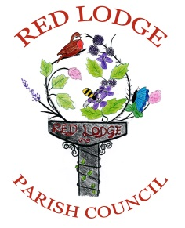
Parish Office, Sports Pavilion, Hundred Acre Way, Red Lodge, Suffolk, IP28 8XR
01638 551257
http://redlodge.onesuffolk.net

Minutes for the Annual Parish Meeting of Red Lodge Parish Council held on 20th May 2014 at the Red Lodge Millennium Centre at 7pm.

Present:
Ben Graveston Chairman
Clare Bloomfield Vice Chair
Roger Dicker
Clive MacLeod BEM
Angie Sewell
6 Parish members in attendance

Apologies: County Cllr Chambers, Cllr Andy Younger, Cllr Andy Drummond & Cllr Carol Downs

The Chairman welcomes members of the Parish to the meeting.

Police Report – form 14th May 2013 to 23rd April 2014 reported crimes have only gone up by 3 from 106 to 109.
The Chairman thanked the Police for the hard work they do throughout the year.

Conservation Group Report – See attached report.

The Parish Council have decided to get 2 defibrillators for the village, one will be at the sports pavilion & the other will be at the Millennium Centre. They are being provided by the British Heart Foundation & NHS, they will also cover the cost of maintenance for these devices.

Question from the Floor –
1. A member of the parish asked what was being done about getting a new village sign. It was explained that the Parish Council are in the process of getting together a working group to deal with this kind of thing in the village & also to get members of the parish involved in the decision making process of what kind of sign is wanted, where it will go etc.
2. The Bollards on Green Lane are constantly being vandalised, the conservation group have spoken to Suffolk Highways Agency but they aren’t responding to the complaint. Green Lane is a Traffic free byway so it is agreed that the Clerk will write a letter to Suffolk Highways Agency.
3. A member of the parish if the signs for the new shops could be made more visually pleasing & have only 1 sign with all the business on it. The Clerk will ask Crest Nicolson if this is something that they can do.
4. A member of the parish asked if the Parish Council will be taking on a new councillor, they were told that as soon as someone comes forward regarding being a part of the Parish Council they can be co-opted on to the Council.

The Next Red Lodge Annual Meeting of the Parish will be held on 26t^{h} May 2015.

Signed ………………………………… Date…………………………..
Chairman

Meeting closed at 8.00pm

